# DriverPass System Design Document

Travis Sands

6/22/2024

## UML Diagrams

### UML Use Case Diagram

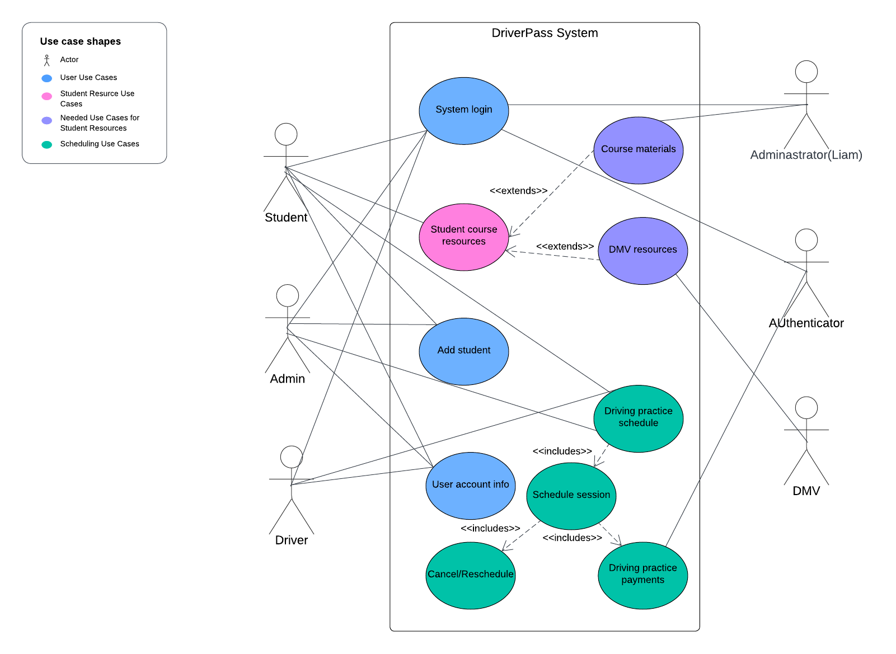

### UML Activity Diagrams

Log In Activity Diagram –

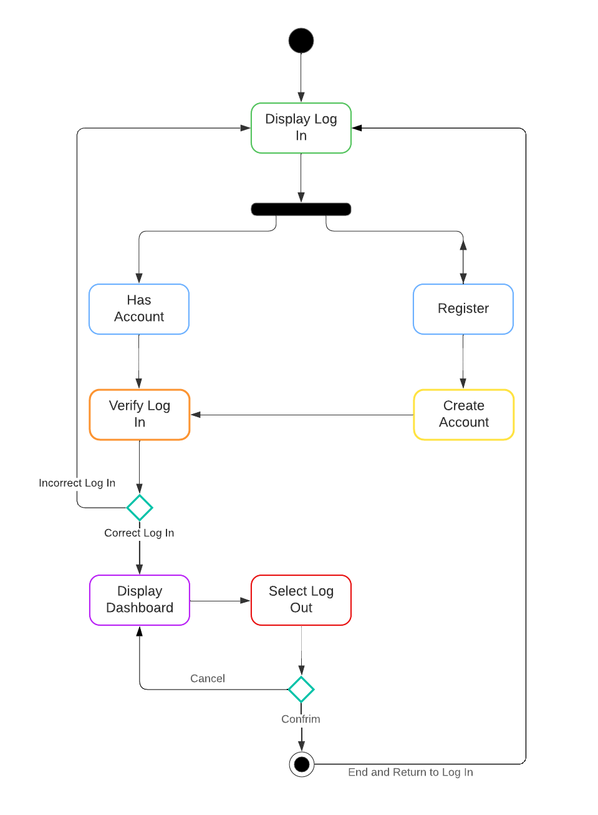

### Driving Schedule Activity Diagram –

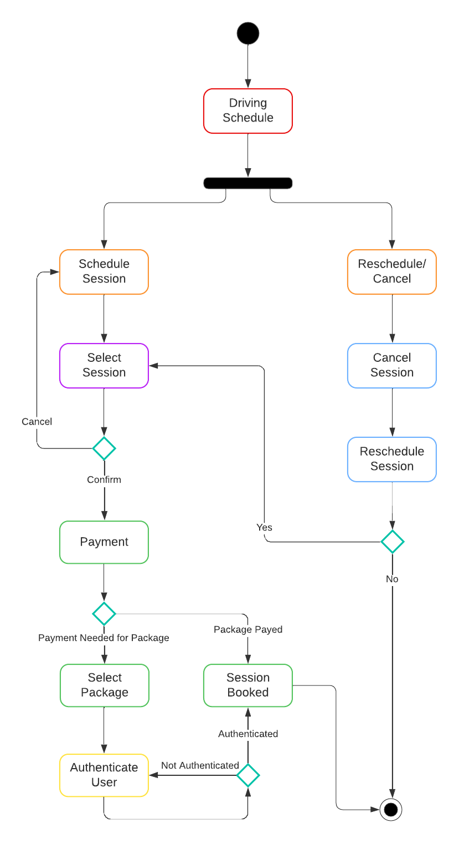

### UML Sequence Diagram

Driving Schedule Sequence Diagram –

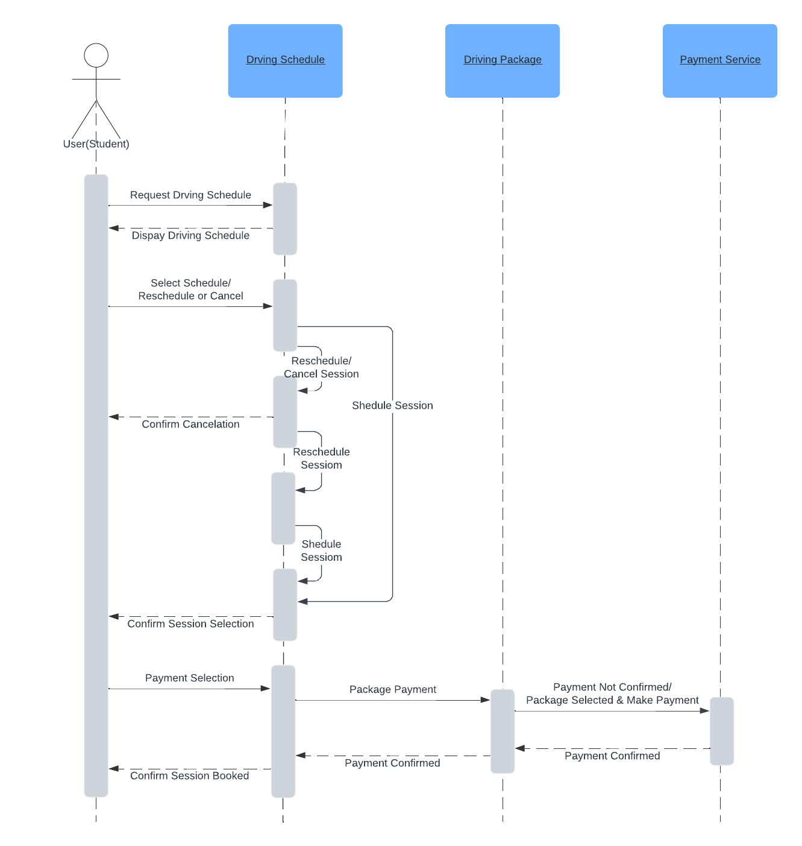

### UML Class Diagram

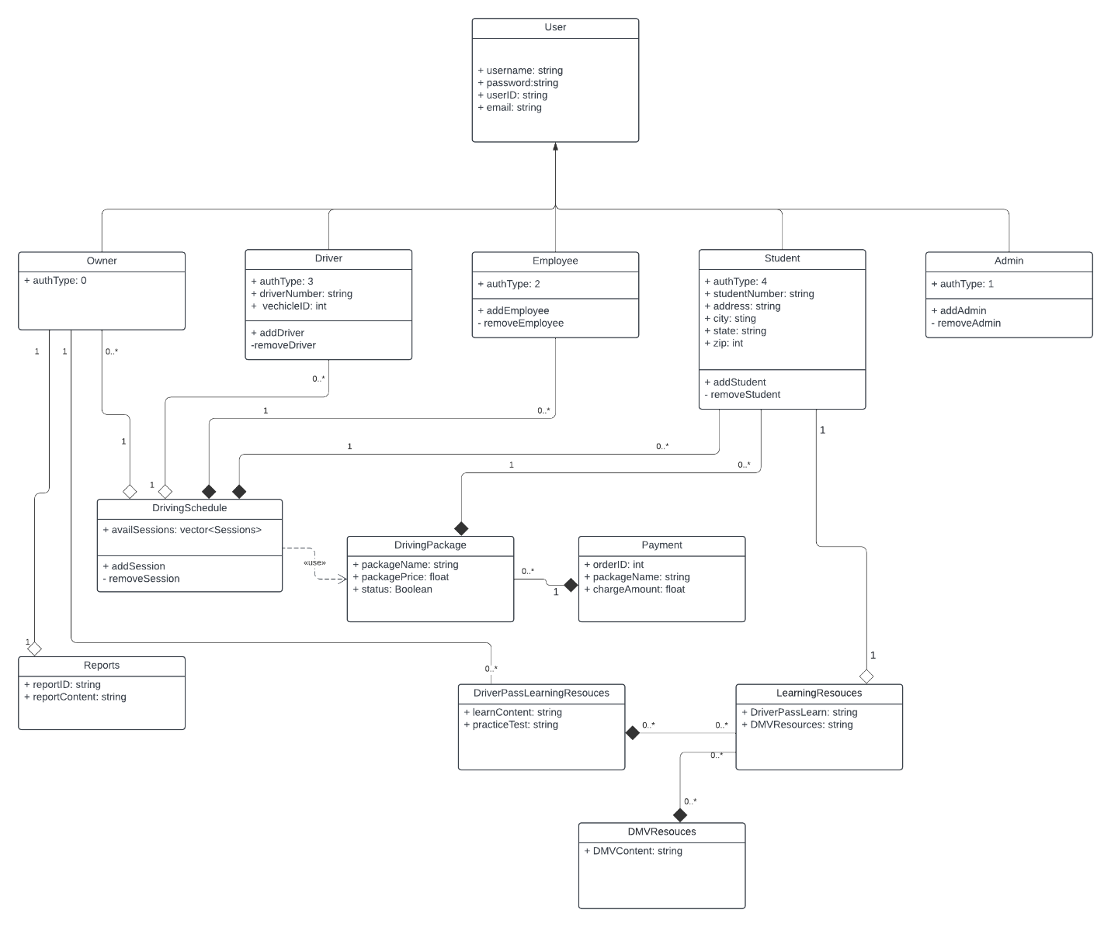

## Technical Requirements

To mitigate the need for servers, the DriverPass application, shall use a cloud service, such as AWS. They software should be written into a web-based application available to all users, including on computers, cell phones, and tablets. The system will validate users and user type when the correct username and password are entered. It should also allow for students and employees to schedule driving sessions with driving instructors. The system will also need to be able to store data, users and their user type and information, as well as pull data from the DriverPass learning modules database and the DMV’s most current database of rules, policies, and laws. As students complete their driving test the results will be updated and shown on the interface. The system will also send reports to Liam the owner and manager of DriverPass.